Republic of the Philippines

BACOLOD WATER DISTRICT

Bacolod Lanao del Norte
TIN 004-367-022
CCC No. 543

CERTIFICATION OF COMPLIANCE
TRANSPARENCY SEAL PROVISION OF THE GENERAL APPROPRIATIONS ACT OF 2017

This certifies that BACOLOD WATER DISTRICT had complied with the provision stated on Section 93 of the General Appropriations Act of FY2017 the “Transparency Seal” provision.

This certifies further that this office maintain a transparency seal on its official website that contains the following information:

- The agency’s mandates and functions, names of its officials with their position and designation, and contact information
- LWUA-reviewed 2017 COB duly approved by the LWD Board
- Quarterly and Annual Financial Reports from FY 2013 to FY 2017
- Projects, Programs and Activities, Beneficiaries, and status of implementation for FY 2017.
- FY 2017 Annual Procurement Plan (APP), which should be posted not later than one month after the issuance of the IATF Circular and subsequently, the approved revisions.
- System of Ranking Delivery Units, which should be posted and disseminated to employees not later than October 1, 2017.
- Agency’s FOI Manual should be uploaded on or before October 1, 2017

This certification is being issued to attest to the truth and accuracy of the foregoing based on available records and information.

This is to further certify that the above mentioned documents and information are posted in the website of the BWD with this Uniform Resource Locator (URL): http://www.bwdldn.gov.ph under a single Transparency Seal icon, prominently located on the home page of the aforementioned website and that the same shall remain unchanged unless otherwise necessitated by circumstances, such as updates, clerical corrections, and similar causes.

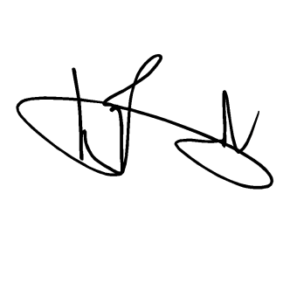
IN WITNESS WHEREOF, we have hereunto affixed our signatures this 1st day of October year 2017 at Bacolod Water District office, Bacolod, Lanao del Norte, Philippines.

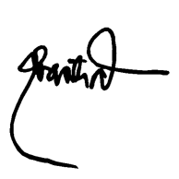

GENALIN A. AMANTIAD ENGR. NOEL L. RESABAL
Human Resource Management Officer-Designate Agency Head

