Republic of the Philippines

BACOLOD WATER DISTRICT

Bacolod Lanao del Norte
TIN 004-367-022
CCC No. 543

CERTIFICATION OF COMPLIANCE
SALN Submission/Filing

This certifies that the Bacolod Water District fully satisfies the Statement of Assets, Liabilities and Net Worth (SALN) requirement for CY 2016.

This also attests that all submissions of the agency concerned has substantially complied with the minimum requisites for content and formalities prescribed under Republic Act 6713 and its Implementing Rules and Regulations, which are as follows:

- Basic information
- Assets (Real Properties and Personal Properties)
- Liabilities
- Net Worth
- Financial Connections and Business Interests
- Relatives in the Government

This further certifies that out of the 11 employees qualified for PBB, 11 have completed and filed their SALN as reflected below:

Office | No. Of Employees | No. Of Employees with Duly Accomplished and Submitted SALN | Percentage of Compliance (%)
Bacolod Water District | 11 | 11 | 100%

The agency has forwarded/filed all SALNS with the appropriate receiving entity ( Office of the Ombudsman for Mindanao, Sta. Ana Davao City) in accordance with RA 6713 and its implementing rules and regulations.
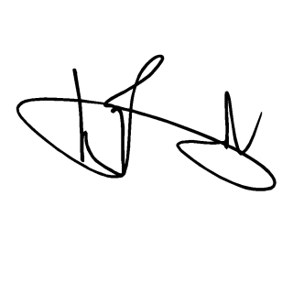
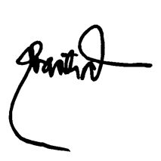
IN WITNESS WHEREOF, we have hereunto affixed our signatures on the 25th day of April year 2017 at Bacolod Water District office, Bacolod, Lanao del Norte, Philippines.

GENALIN A. AMANTIAD ENGR. NOEL L. RESABAL
Chairman Agency Head
SALN Review and Compliance Committee
HRMO-Designate

