ANNEX 2

FORM A-1
DETAILS OF DELIVERY UNIT/OFFICE PERFORMANCE INDICATORS AND TARGETS*

LWD NAME: BACOLOD WATER DISTRICT – LANAO DEL NORTE

Major Final Outputs/Responsible  Bureaus  (1) | Performance Indicator 1  (2) | FY 2017 TARGET for Performance Indicator 1  (3) | FY 2017  ACCOMPLISHMENT  for Performance  Indicator 1  (4) | Performance  Indicator 2  (5) | FY 2017  TARGET for Performance Indicator 2  (6) | FY 2017  ACCOMPLISHMENT  for Performance  Indicator 2  (7) | Performance Indicator n  (8) | FY 2017  TARGET for Performance Indicator n  (9) | FY 2017  ACCOMPLISHMENT  for Performance  Indicator n  (7) | Remarks  (11)
A. Water Facility Service Management
Delivery Unit (Operation and Technical Section) | Completed 100% of all the line activities | 100% completion of all the line activities | 100% completion of all the line activities | All line activities are completed without complaint | All line activities are completed without complaint | All line activities are completed without complaint | All line activities are completed on time/ without delay | All line activities are completed on time/ without delay | All line activities are completed on time/ without delay
B. Water Distribution Service Management
Delivery Unit (Operation and Technical Section) | Completed 100% of all the line activities | 100% completion of all the line activities | 100% completion of all the line activities | All line activities are completed without complaint | All line activities are completed without complaint | All line activities are completed without complaint | All line activities are completed on time/ without delay | All line activities are completed on time/ without delay | All line activities are completed on time/ without delay
B. Support to Operation (STO) |  |  |  |  |  |  |  |  |  |  |  |  |  |  |  | B. Support to Operation (STO)
Delivery Unit (Commercial Section) | Completed 100% of all reports and line activities | 100% completion of all reports and line activities | 100% completion of all reports and line activities | All reports done without error | All reports done without error | All reports done without error | All reports done on or before the scheduled time | All reports done on or before the scheduled time | All reports done on or before the scheduled time
C. General Administration and Support Services (GASS)
Delivery Unit (Finance and Admin Section) | Completed 100% of all reports and line activities | 100% completion of all reports and line activities | 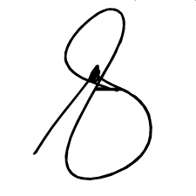  100% completion of all reports and line activities | All reports done without error | All reports done without error | All reports done without error | All reports done on or before the scheduled time | All reports done on or before the scheduled time | All reports done on or before the scheduled time
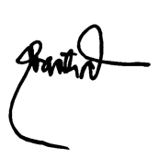
Prepared by:

GENALIN A. AMANTIAD January 12, 2018 ALMA S. MAGLANA January 12, 2018
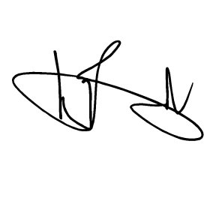
Planning Officer Date Budget Officer Date

Approved by:

ENGR. NOEL L. RESABAL January 12, 2018
Agency Head Date

