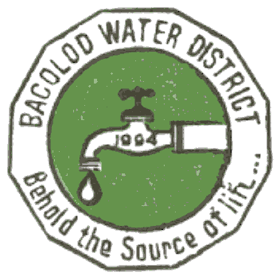 | Republic of the Philippines  BACOLOD WATER DISTRICT  Bacolod Lanao del Norte  TIN 004-367-022  CCC No. 543
CERTIFICATION OF COMPLIANCE
PhilGEPS Posting

This is to certify that the BACOLOD WATER DISTRICT, has posted the Invitations to Bid (ITB), Requests for Expression of Interest (REI), Request for Quotations, (RFQ) Notices of Award/Bid Results, the Actual Approved/Awarded Contracts and Notices to Proceed/Purchase Orders (P.O.s) for all the projects listed below at the Philippine Government Electronic Procurement System (PhilGEPS), for the period covered from November 16, 2016 to November 15, 2017, to wit:

# | Reference  No | Date of Posting of Invitation to Bid/REI | Bid Notice Title | Closing Date | Date of Posting Of Notice of Award | Date of Posting of P.O./ Approved Contract and Notice to Proceed | Bid Notice Status | Created  By | Remarks
1 | 4221236 | 29-Nov-16 | Invitation to Bid | 6-Dec-16 | - | - | Failed | zligutom | Failure of bidding not even a single bid submitted

This is to further certify that the list includes all projects procured by the BACOLOD WATER DISTRICT as of November 15, 2017.

This certification is being issued to attest to the truth and accuracy of all the foregoing based on available records and information that can be verified with the PhilGEPS

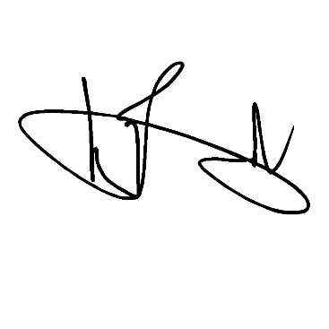
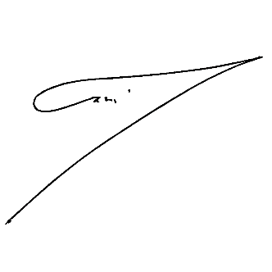
IN WITNESS WHEREOF, we have hereunto affixed our signatures on the 15th day of November 2017 at Bacolod (Lanao del Norte) Water District office, Bacolod, Lanao del Norte, Philippines
Signed by: Signed by:

ZAIDIE C. LIGUTOM ENGR. NOEL L. RESABAL
BAC Chairperson Head of the Procuring Entity

Date: November 15, 2017 Date: November 15, 2017

