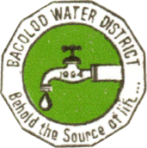
BACOLOD WATER DISTRICT
Bacolod, Lanao del Norte
CCC NO. 543

BWD PROGRAMS AND PROJECTS
As of December 31, 2017

No. | Project  Program  Activity Name | Location  Target Beneficiaries | Total  Cost |  | Date  Started | Status of Project Implementation
 |  |  |  |  |  | Target  Completion  Date | Actual  Completion Date | % of Completion | Total  Cost Incurred | Remarks
1 | Two-Storey Office Building | Purok 3, Bacolod, LDN | P 3,500,000.00 |  | January 3, 2017 | December 31, 2017 | August 10, 2017 | 100% | P 3,500,000.00 | Fully Implemented
Total Project Cost P 3,500,000.00
Prepared by:  ZAIDIE C. LIGUTOM  UCSA-C |  |  |  | Checked by:  ALMA S. MAGLANA  Corporate Accounts Analyst |  |  | Approved by:  ENGR. NOEL L. RESABAL  General Manager

