Republic of the Philippines

BACOLOD WATER DISTRICT

Bacolod Lanao del Norte
TIN 004-367-022
CCC No. 543

GUIDELINES / MECHANICS IN RANKING OFFICES / DELIVERY UNITS
FOR THE GRANT OF PERFORMANCE –BASED BONUS (PBB) FY 2016

In view of the Local Water Utilities Administration (LWUA) – Department of Budget and Management (DBM) Memorandum Circular No. 2014-02, LWUA Memorandum Circular No. 015.16 dated October 21, 2016, the Inter-Agency Task Force (IATF) on the Harmonization of National Government Performance Monitoring, Information and Reporting Systems Memorandum Circular No. 2016-1, and Executive Order No. 80, please be informed that the following System of Ranking of Delivery Units for the Grant of Performance – Based Bonus for year 2016 is hereby adopted for implementation:

Coverage

The Performance-Based Bonus shall be granted to qualified permanent and casual employees of BWD.

- Ranking of Delivery Units

- “Delivery Units” as defined in the LWUA Memorandum Circular 015.16 refer to Offices or Group according to Category per Local Water District Manual on Categorization, Recategorization and Other Related Matters (LWD-MaCRO). Hence, in view of the substantial functions of each Office/Group, coming as responsible units in achieving BWD’s MFOs, “delivery units” shall be referring to the OFFICE or GROUP, established and functional per Organizational Structure approved by DBM as per Personal Services Itemization and Plantilla of Personnel (PSIPOP) for the year 2016.

Category D – LWD Organizational Structure per PSIPOP

- Office of the General Manager
- Administrative Section
- Finance Service Section
- Commercial Service Section
- Operations/Technical Section

- To determine the ranking of Office/Group as “delivery units”, the average final performance rating of qualified employees for the period January to June 2016 and July to December 2016 will be computed.

- Following the provisions of LWUA and IATF Memorandum Circulars, item 8.1 of MC No. 2016-1 (May 12, 2016) states that bureaus, offices or delivery units eligible to the PBB shall be forced ranked according to the following:

Ranking | Performance Category
Top 10% | Best Bureau/Office/Delivery Unit
Next 25% | Better Bureau/Office/Delivery Unit
Next 65% | Good Bureau/Office/Delivery Unit

- Eligibility of Individual Employees

- Employees belonging to the First and Second Levels should receive at least “Satisfactory” based on the Agency’s CSC – Approved Strategic Performance Management System are eligible to receive the PBB. The final rating of each employee shall be confirmed by the Head of the Agency.

- The Head of the Agency is qualified to receive the highest incentive of the PBB.

- An employee or official who has rendered a minimum of nine (9) months of service in FY 2016 and with at least Satisfactory rating may be eligible to the full grant of PBB

- An employee who rendered less than nine (9) months but minimum of three (3) months but with at least Satisfactory performance rating shall be eligible to the grant of PBB on a pro-rated basis, corresponding to the actual length of service rendered, as follows:

Length of Service | % of PBB
8 months but less than 9 months  7 months but less than 8 months  6 months but less than 7 months  5 months but less than 6 months  4 months but less than 5 months  3 months but less than 4 months | 90%  80%  70%  60%  50%  40%

The following are the valid reasons for an employee who may not meet the nine-month actual service requirement to be considered for PBB on a pro-rated basis:

- Being a newly hired employee
- Retirement
- Resignation
- Rehabilitation Leave
- Maternity Leave and / or Paternity Leave
- Vacation or Sick Leave with or without pay
- Scholarship / Study Leave
- Sabbatical Leave
- Employees who are Not Entitled to Receive PBB

The following are excluded from the grant of PBB:

- An employee who is on vacation or sick leave with or without pay for the entire year is not eligible to the grant of PBB.

- Employees who failed to submit their complete SPMS forms and employees who have not rendered at least three (3) months of service in year 2016.

- For employees who are found guilty of any administrative charges and/or criminal charges related to their work for year 2016, the reckoning date for disqualification of benefits is the date of Order by the General Manager.

- Officials and employees who failed to submit SALN prescribed in the rules under CSC MC No. 3, s. 2015.

- Officials and employees who failed to liquidate within the prescribed period the CAs received in FY 2016.

- Rates of FY 2016 PBB

The PBB rates of individual employees shall depend on the performance ranking of the bureau or delivery units where they belong based on the individual’s monthly basic salary as of December 31, 2016 as follows, but not lower than Php 5,000.00

Performance of Eligible Agency | PBB as % of Monthly Basic Salary
Best Bureau/Office/Delivery Unit | 65%
Better Bureau/Office/Delivery Unit | 57.5%
Good Bureau/Office/Delivery Unit | 50%

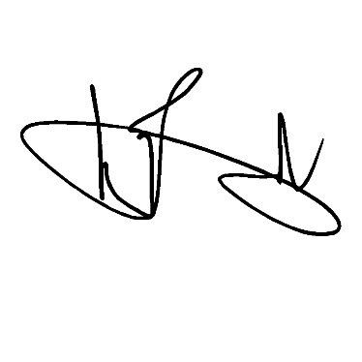
Furthermore, as one of the key players of the SPMS, the Performance Management Team (PMT) shall act as appeals body and the final arbiter for performance management issues of the agency.

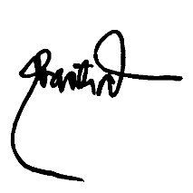

GENALIN A. AMANTIAD ENGR. NOEL L. RESABAL
Human Resource Management Officer-Designate General Manager

