Annex F

CoC Template

CERTIFICATION OF COMPLIANCE
(Pursuant to Republic Act 9485: An Act to Improve Efficiency in the Delivery of Government Service to the Public by Reducing Bureaucratic Red Tape, Preventing Graft and Corruption, and Providing Penalties Therefor)

I, ENGR. NOEL L. RESABAL, Filipino, of legal age, General Manager of the Bacolod Water District located at Poblacion, Bacolod, Lanao del Norte being responsible and accountable in ensuring compliance with Section 6 of the Anti-Red Tape Act of 2007 and Rule IV of its Implementing Rules and Regulations, hereby declare and certify that the Bacolod Water District has no deficiency identified during the Citizen’s Charter validation conducted on September 30, 2016 by DIRECTOR ALONA B. CARUMBA.

This certification is being issued to attest the truth and accuracy of all information contained herein based on available records and information that can be verified with the Bacolod Water District.

IN WITNESS HEREOF, I hereunto set my hand this 30th day of September 2016 in Bacolod Water District Office, Poblacion, Bacolod, Lanao del Norte, Philippines.
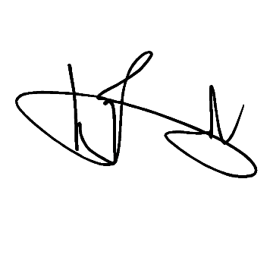

ENGR. NOEL L. RESABAL
Head of Agency

General Manager
Position

