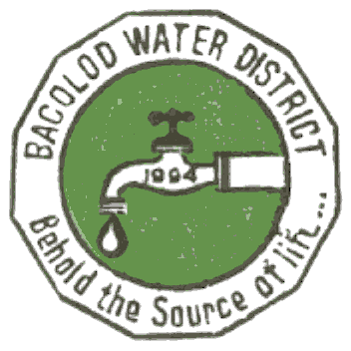 | Republic of the Philippines  BACOLOD WATER DISTRICT  Bacolod Lanao del Norte  TIN 004-367-022  CCC No. 543

GUIDELINES/MECHANICS IN RANKING OFFICES/DELIVERY UNITS AND INDIVIDUAL FOR THE GRANT OF PERFORMANCE-BASED BONUS (PBB) FOR 2015

Guidelines and process in determining and evaluation of the performance ranking and rating of offices and employee within the Bacolod Water District

- Approved by the Civil Service Commission the Bacolod Water District Guidelines in the Establishment of Strategic Performance Management System

- Office Performance Commitment and Review – (January – June 2015)

- Office Performance Commitment and Review – (July – December 2015)

- Individual Performance Commitment and Review – (January – June 2015)

- Individual Performance Commitment and Review – (July – December 2015)

Prepared by:

GENALIN A. AMANTIAD
Human Resources Management Officer – Designate

Noted by: Approved by:

ENGR. NOEL L. RESABAL ELSA P. PANORIL
General Manager BOD Chairman

