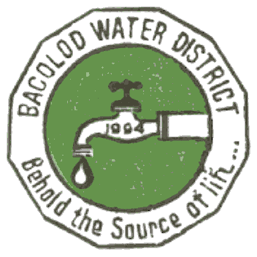 | Republic of the Philippines  BACOLOD WATER DISTRICT  Bacolod Lanao del Norte  TIN 004-367-022  CCC No. 543

Certificate of No PhilGEPS Posting

This is to certify that Bacolod (Lanao del Norte) Water District has no PhilGEPS postings for projects with an approved budget for the contract of above Php500,000.00 for the period of January 1, 2015 to November 15, 2015 due to the following reason(s):

(_____) Centralized Procurement
(___√_) Procurement undertaken by the Procurement Agent.
Please provide procurement agent in the space provided below:
- __ENGR. NOEL L. RESABAL___________________________
- _______________________________________________
( √ ) Others, please specify No purchases/projects above P500,000.00

This certification is being issued to attest to the truth and accuracy of the foregoing based on available records and information.

IN WITNESS WHEREOF, we have hereunto affixed our signatures this 24th day of November 2015 at Bacolod (Lanao del Norte) Water District office, Bacolod, Lanao del Norte, Philippines

ZAIDIE C. LIGUTOM ENGR. NOEL L. RESABAL
BAC Chairperson Head of the Procuring Entity

