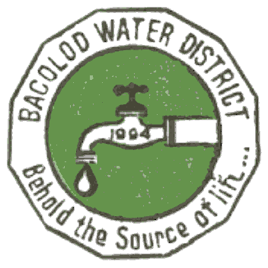 | Republic of the Philippines  BACOLOD WATER DISTRICT  Bacolod Lanao del Norte  TIN 004-367-022  CCC No. 543

CERTIFICATION OF COMPLIANCE

Pursuant to Republic Act 9485: An Act to Improve Efficiency in the Delivery of Government Service to the Public by Reducing Bureaucratic Red Tape, Preventing Graft and Corruption and Providing Penalties Therefore

I, NOEL L. RESABAL, Filipino, of legal age, General Manager of the Bacolod Water District being responsible and accountable in ensuring compliance with Section 6 of the Anti-Red Tape Act of 2007 and Rule IV of its Implementing Rules and Regulations, hereby declare and certify the following truths:

- The Bacolod Water District has established its service standards known as the Citizen’s Charter that enumerates the following:
- Vision and mission of the agency
- Frontline services offered
- Step-by-step procedure in availing of frontline services
- Employee responsible for each step
- Time needed to complete the procedure
- Amount of fees
- Required documents
- Procedure for filing complaints
- The Citizen’s Charter is posted as information billboards in all the service offices of Bacolod Water District that deliver frontline services.
- The Citizen’s Charter is positioned at the main entrance of the office or at the most conspicuous place of all the said service offices.
- The Citizen’s Charter is written either in English, Filipino, or in the local dialect and published as an information material (e.g. booklet or brochure).
- The Citizen’s Charter is uploaded in the agency’s website and accessible to the public.
- The Citizen’s Charter was first published in 2011 and underwent review and revision on January 2015 as required under Section 4, Rule IV of the IRR: The office or agency shall review the Citizen’s Charter whenever necessary, but not less than once every two years.
- The Citizen’s Charter already shows the improvements that resulted from the process review of frontline service delivery, specifically shortened turnaround time, reduction on the number of signatories and streamlining of procedures, to wit:

PROCESS | EXISTING | IMPROVEMENTS
NSC Application | From 4 signatories to 2 signatories | Reduction in the number of signatories
Attendance to concessionaires complaints | From 2 hours to 1 hour | Shortened turnaround time
Attendance to service request | From 5 steps to 3 steps | Streamlining of procedures

This certification is being issued to attest to the accuracy of all the foregoing based on available records and information that can be verified.
IN WITNESS HEREOF, I have hereunto set my hand this 16th day of January 2015 in Bacolod, Lanao del Norte, Philippines.

ENGR. NOEL L. RESABAL
Head of Agency

